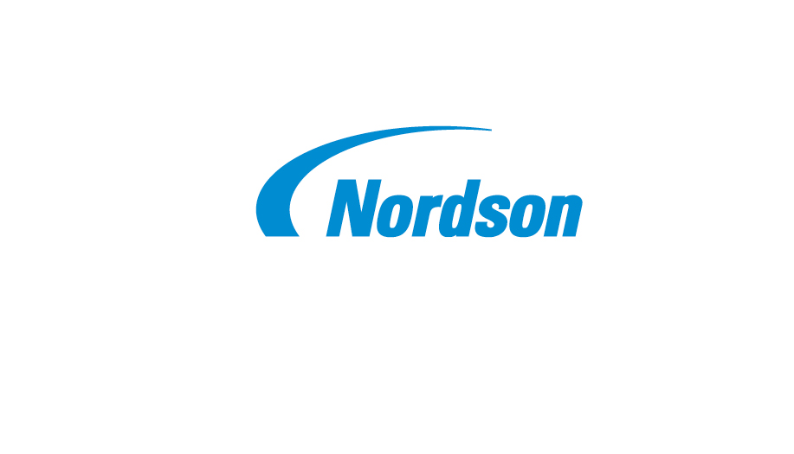
News Release
Address
City, State Zip
Country

FOR RELEASE: Immediately
CONTACT: Full Name
Phone
Email

This is the News Release Headline – The Style Should Be Upper and Lower Case, Do Not Use All Capital Letters

- Subheadline if required goes here – initial capital letter only
City, State, Country – Date - Body text begins here. Et harum quidem rerum facilis est et expedita distinctio. Nam libero tempore, cum soluta nobis est eligendi optio cumque nihil impedit quo minus id.

More body text. Et expedita distinctio. Nam libero tempore, cum soluta nobis est eligendi. Lorem ipsum dolor sit amet, consectetur adipisicing elit, sed do eiusmod tempor incididunt ut labore dolore magna aliqua. Ut enim ad minim veniam, quis nostrud exercitation ullamco.

TO EDIT the CONTACT and ADDRESS AREAS, click in the text area you would like to edit and then make your changes. When changes are complete, SAVE the document to your computer.

Optional paragraph here providing information about the specific Nordson business or segment issuing the news release. This is not required.

Nordson Corporation is an innovative precision technology company that leverages a scalable growth framework to deliver top-tier growth with leading margins and returns. The Company’s direct sales model and applications expertise serves global customers through a wide variety of critical applications. Its diverse end market exposure includes consumer non-durable, medical, electronics and industrial end markets. Founded in 1954 and headquartered in Westlake, Ohio, the Company has operations and support offices in over 35 countries. Visit Nordson on the web at www.nordson.com, www.twitter.com/Nordson_Corp or www.facebook.com/nordson.

# # #

