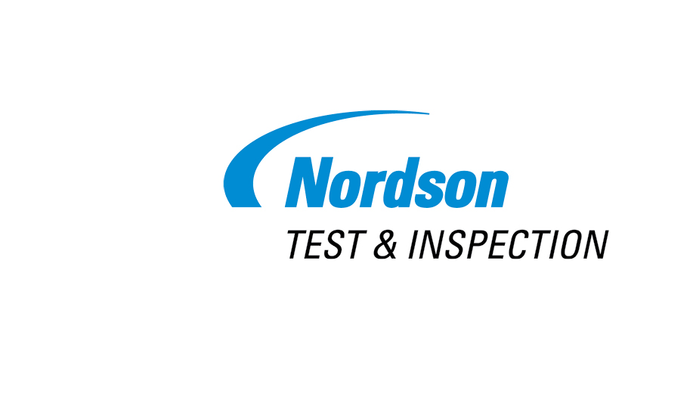

News Release

Address

City, State Zip

Country

**FOR RELEASE:** Immediately

**CONTACT:** Full Name

Phone

Email

This is the News Release Headline – The Style Should Be Upper and Lower Case, Do Not Use All Capital Letters

* **Subheadline if required goes here – initial capital letter only**

**City, State, Country – Date -** Body text begins here. Et harum quidem rerum facilis est et expedita distinctio. Nam libero tempore, cum soluta nobis est eligendi optio cumque nihil impedit quo minus id.

More body text. Et expedita distinctio. Nam libero tempore, cum soluta nobis est eligendi. Lorem ipsum dolor sit amet, consectetur adipisicing elit, sed do eiusmod tempor incididunt ut labore dolore magna aliqua. Ut enim ad minim veniam, quis nostrud exercitation ullamco.

TO EDIT the CONTACT and ADDRESS AREAS, click in the text area you would like to edit and then make your changes. When changes are complete, SAVE the document to your computer.

Optional paragraph here providing information about the specific Nordson business or segment issuing the news release. This is not required.

Nordson Corporation (Nasdaq: NDSN) is one of the world’s leading producers of precision dispensing equipment that applies adhesives, sealants, coatings and other materials to a broad range of consumer and industrial products during manufacturing operations. The company also manufactures equipment used in the testing and inspection of electronic components as well as technology-based systems for curing and surface treatment processes. Headquartered in Westlake, Ohio, Nordson has direct operations and sales support offices in more than 30 countries.

# # #